**First Payment Reminder**

To whom it may concern,

Our records show that we haven’t yet received payment for your most recent invoice, which is overdue by 7 days. I would appreciate if you could check this on your end.

To ensure that the members of your group scheme are always fully covered, it is very important that your premium is paid as soon as possible.

If the payment has already been sent, please disregard this notice.

If you have any questions, please contact us by calling the Corporate Accounts team on 01 5625303 (Monday–Friday,9am–5pm) or by email corporate.accounts@irishlifehealth.ie and we’d be happy to help.

Yours sincerely,

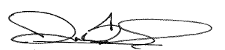

Darran Bennis

Senior Manager– Commercial Operations